(Taylor, 2022)(Taylor, 2022)

Table of Contents

1. Introduction: 3

1.1 Problem Scenario 3

1.2 Project as a solution 4

2. Aims and Objectives: 5

3. Expected Outcomes and Deliverables 6

3.1 Primary Features 6

3.2 Secondary Features 7

4. Project risks, threats and contingency plan 8

4.1 Risks 8

4.2 Contingency Plans 8

5. Methodology 9

6. Resource Requirements: 11

7. Work Breakdown Structure 11

8. Milestone 12

9. Gantt Chart 13

6. Conclusion 14

Bibliography 14

# Introduction:

First thing a person search for while planning to migrate from one place to another is a place to stay after reaching the destination. A room/apartment is mostly preferred by the students and working professionals who constantly need to travel from one place to another. However, there is no reliable platform for you to find a room/apartment of your choice. This complicates things a lot as you cannot shift to a new place without finding a home to stay and searching on the physical site may not be possible for most people.

The product being built for this project is room/apartment finding web application which will help the customers to negotiate or make a deal the property directly with the owner and to make the user experience as effective and efficient as possible this project will have maximum time limit/expiry-date of 1 month on the ads of the property posted by the user. A user can be a customer and seller as he/she can buy a property and sell their own property.

## Problem Scenario

1. People need to roam physically to find a room or apartment either to buy or rent.
2. There are few websites which claim to help people to find the property of their type however, most of them are run by the agencies however they are not active on the website.
3. There is no dedicated platform for the customer to find the property they need without any
4. As there are no alternatives for finding the property the customer need, finding the room for people who are planning to shift to major cities of Nepal face a lot of problems especially for students and working professionals as they don’t have their established source of income and time on their hand to roam around to search physically.
5. Most websites in Nepal which claims to help find people property to live in they got too old ads like 5–6-year-old which makes the experience for the customer troublesome.

## Project as a solution

This project will act as the best possible solution for the above-mentioned problem in the context of Nepal. With the time limit on the ad of property posted by the seller, customer can benefit the most as they will get to know how old the ad is and since there will no ads that are of before 30-day customer can surf the website with ease to find the property they need.

People can directly interact with the owner by using the contact info given by the owner on the post or in the comment section of the property ad’s details. The details on the ad include property details, owner details, property location and picture of property and surrounding. There will also be the embedded map which shows the location of the property so the customer can easily go and visit the owner in person and deal with them. Maps will further show the nearby schools, Hospitals, Markets near the property.

# 1.Aims and Objectives:

The aim of this project is to create a room finding web application. Which can solve the above mention problems people are facing while finding the rooms in major cities of Nepal.

**Objectives**

The objectives which are the basis of the completion of the project are:

1. To learn about web application and their workings.
2. To use build a room finder web application at the end of the project
3. To understand and implement usage of database along with web application.
4. To learn about user interface.
5. To understand about API programming.
6. To deliver a complete functional product at the end of the project

# Structure of Report

* 1. **Introduction**

Introduction consists of information about project, problem domain, end

users, project scope, aims and objectives of the project.

* 1. **Background/Literature review**
  2. **Development to date**

In Development to date chapter, progress of project is included.

* 1. **Analysis of progress**

Analysis of progress chapter include the progress analysis to obtain the

information on the state of project, how it is being developed? This chapter

helps to determine the actual progress of project according to Gantt chart.

* 1. **Future work**

Future work includes the remaining task of this project to be carried out in

future.

* 1. **References**

In references section, it included all the references that are taken as

reference while doing this project, report.

* 1. **Appendix**

In appendix sections, it contains the brief description of SRS document, high level use case diagram and wireframes with screenshot. Similarly, relationship between entities are explained. Data dictionary of each entity is kept. Additionally,it included brief description of project as solution, considered and selected methodology. Thus, scanning images of survey done at parking location, screen shot of android and web code are kept

here.

# Background/Literature review

A room/apartment finder web application is a tool that allows users to search for rental properties, such as apartments, rooms, or houses, in a specific location. These types of applications are commonly used by people who are looking for a place to live, either temporarily or permanently. Users can consider various factors when searching for a rental property, including location, price, size, and amenities. Some room/apartment finder web applications may also offer features like the ability to filter search results by these criteria, view photos and virtual tours of the properties, and contact landlords or property managers directly through the application.

The use of online platforms can make the process of searching for a rental property more efficient by allowing users to quickly and easily compare different properties and contact landlords or property managers directly. This can also increase the transparency and fairness of the rental market, as users can access a wider range of properties and landlords can find qualified tenants more easily.

In addition to benefits for users and landlords, room/apartment finder web applications can also be beneficial for cities and communities. These types of applications can help reduce vacancy rates and improve the overall supply and demand balance in the rental market, and can also increase the mobility of residents by making it easier for people to find and move to new rental properties. Overall, room/apartment finder web applications provide a convenient and efficient way for people to find rental properties and can have a positive impact on the rental market and communities.

## Similar Projects

* + 1. **Room Finder Nepal**

Roomsfindernepal is a weion. web-based application. Rooms Finder Nepal is located at: Manamaiju, Kathmandu, Nepal 46000. According to alexa, roomsfindernepal.com has a global rank of #6991232 and it has some SEO issue. This site allows people to search for the property people need in their web.

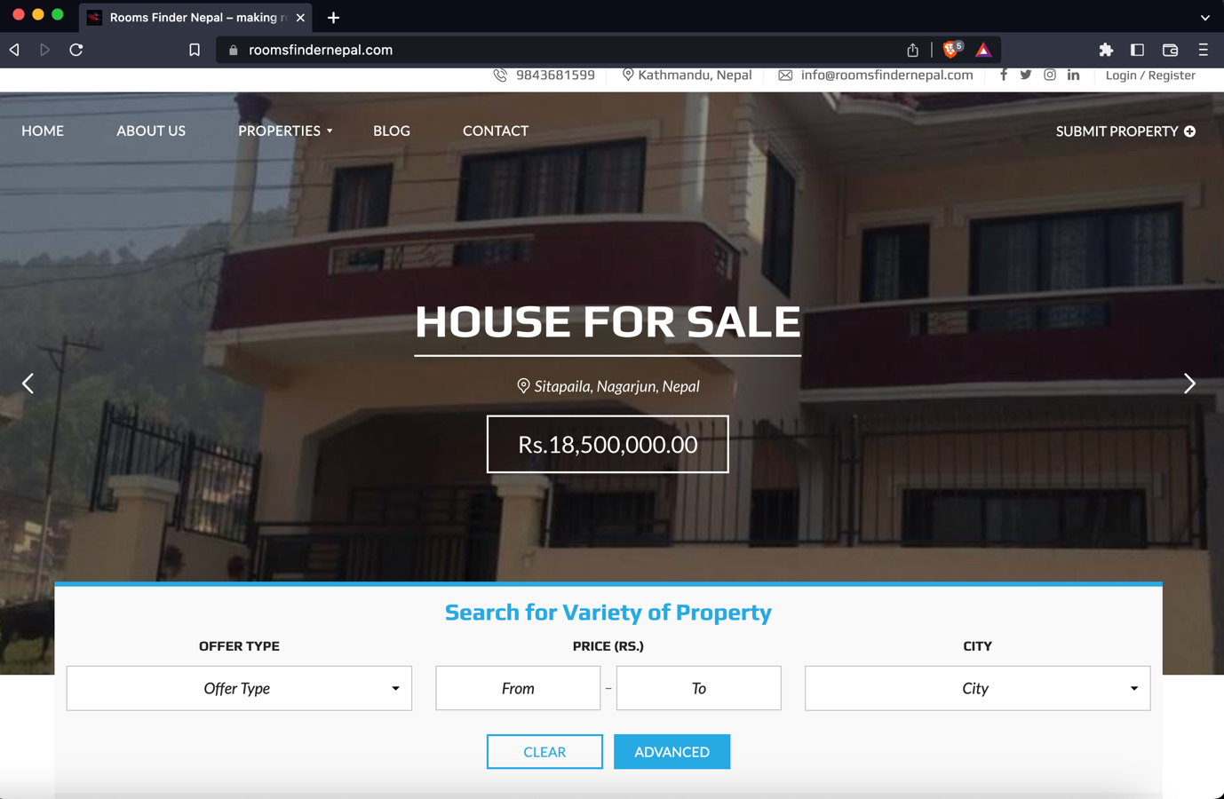

* + 1. **Gharbeti**

Gharbeti is a web portal designed to reshape the conventional pattern of rental and real estate solution for building, flat, room, space, apartment, hostel, and land all around Nepal. This portal allows people to search and book properties from available property list via online presence. The properties are displayed in categorical lists where clients can search the property that best suits their budget range as well as location. The list is regularly updated by our marketing team; the team searches property manually as well as encourages and advocates property owners to post through online with detail information of property.

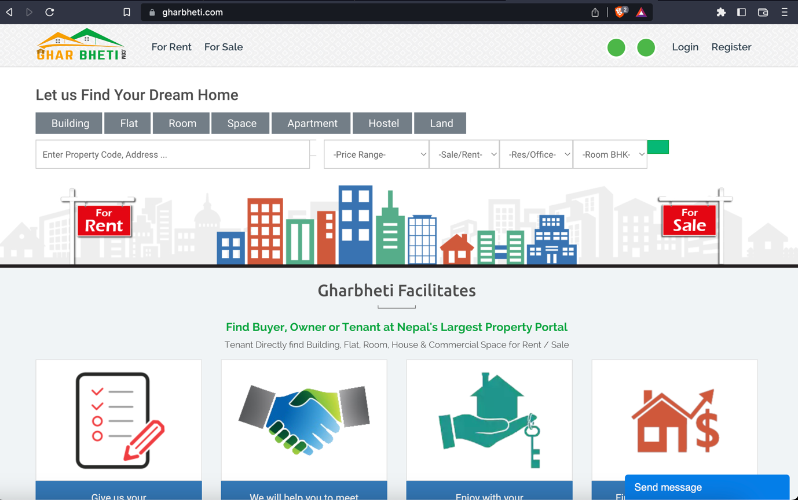

* + 1. **Dalay Dai**

DalayDai.com is a free online platform for buying and selling Houses, Lands and everything Real Estate. We at dalaydai.com are committed to make, searching a perfect Home or a perfect plot of Land for Nepali people effortless and easy like it has never been. With frequent updates to the platform we assure our customers that, you, will have a very smooth and enjoyable experience buying or selling Real Estate with DalayDai.com.

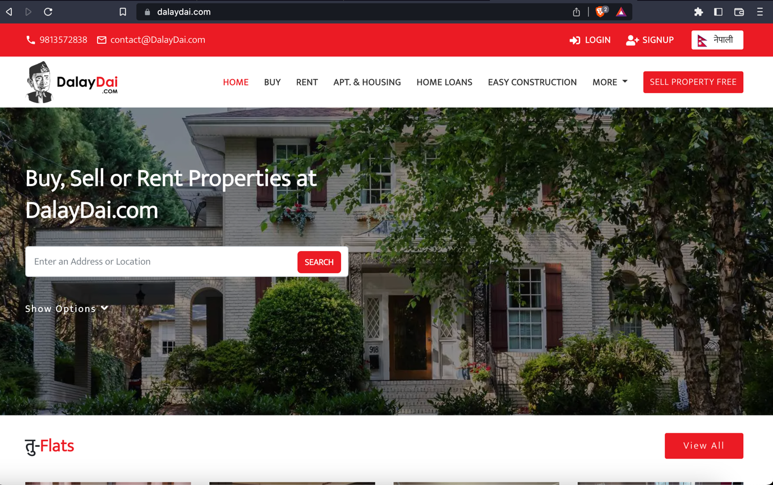

* + 1. **Hamro Rental**

DalayDai.com is a free online platform for buying and selling Houses, Lands and everything Real Estate. We at dalaydai.com are committed to make, searching a perfect Home or a perfect plot of Land for Nepali people effortless and easy like it has never been. With frequent updates to the platform we assure our customers that, you, will have a very smooth and enjoyable experience buying or selling Real Estate with DalayDai.com. (**NEED TO BE CHANGED**)

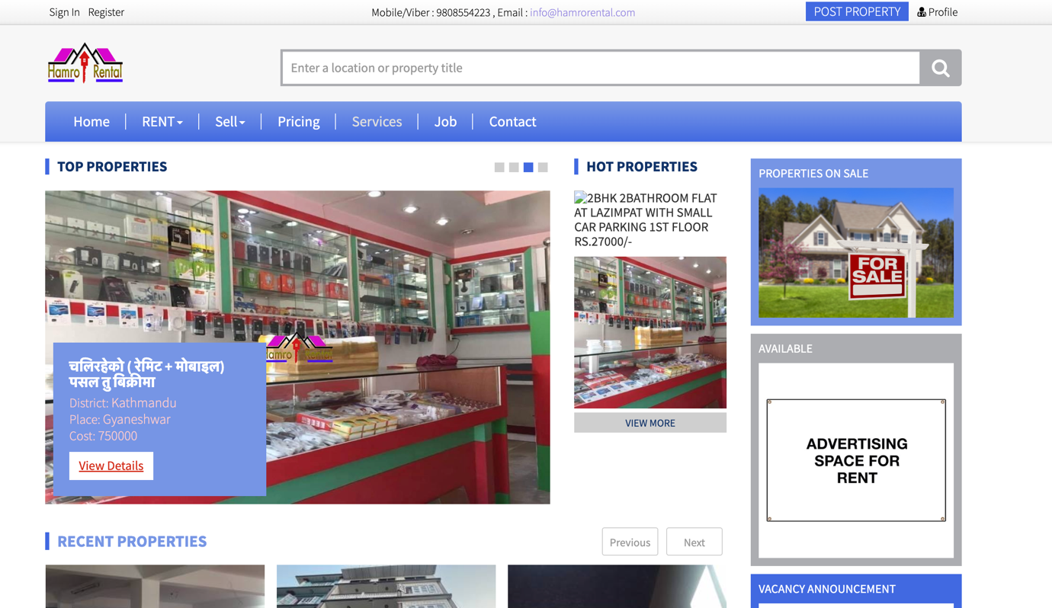

|  |  |  |  |  |  |  |
| --- | --- | --- | --- | --- | --- | --- |
| **S.N.** | **Features** | **Similar Projects** | | | | |
| **Room Finder Nepal** | **Gharbeti** | **DalayDai** | **Hamro Rental** | **MYRoom (My Project)** |
| **1** | Advance Search Feature | **Checkmark** |  |  |  | **Checkmark** |
| **2** | Wishlist |  |  |  |  | **Checkmark** |
| **3** | Location |  |  |  |  | **Checkmark** |
| **4** | Ad Expiry Time |  |  |  |  | **Checkmark** |
| **5** | Comments in ads |  |  |  |  | **Checkmark** |
| **6** | Chat |  |  |  |  | **Checkmark** |
| **7** | Report unreliable ads |  |  |  |  | **Checkmark** |
| **8** | Pet Allowed Filter | **No sign** | **No sign** | **No sign** | **No sign** | **Checkmark** |
| **9** | Show Nearby Schools, Markets, Hospitals in map view for property | **No sign** | **No sign** | **No sign** | **No sign** | **Checkmark** |
| **10** | Upload Video tour for the property | **No sign** | **No sign** | **No sign** | **No sign** | **Checkmark** |

* 1. **Comparison between the system.**

# Expected Outcomes and Deliverables

After the completion of project, a web application that will be helpful to find the room or property people need, can be expected.

## Primary Features

* 1. Online Ad Posting of the property to rent
  2. Seller can Specify either to lease or to sell
  3. The user is divided into buyer and seller however they both can sell or buy the property listed.
  4. There will be the expiry date of 30 days on every ad posted.
  5. Time passed after the ad is posted will be visible to the user
  6. The ad posted by the seller will disappear after the expiry time passes and the seller will be notified about the removal of ad.
  7. The seller could further decide to repost the ad is the property is not yet sold out or rented.
  8. Embedded map will be shown in the details of the property added by the seller which is a must and seller cannot post any property without the map showing property’s location.
  9. There will be a section for the images of the property including the surrounding of the property, seller should upload the image of the property before making the ad publicly available.
  10. Property filter option will be available to the users which will help the user filter the property listed for “Rent Only” , “Buy Only” & “Rent or Buy Both”
  11. User can search up for the property they want, further this function enables user to search the property based on nature of the property like location, price range, recent ads, property size, etc.
  12. Buyer will be able to choose the property they want and add it to their Wishlist.
  13. Seller can specify what luxury or facilities are available in the property they are selling like, furnished or non-furnished , parking space, Water, Electricity, bathroom, etc.

## Secondary Feature

* + 1. Near-by schools/ markets and hospitals can be seen easily in the map for property
    2. Property filter with pets allowed or not allowed
    3. Seller could upload videos of the property through which buyer can have virtual tour of the property
    4. Buyers could directly ask question to the sellers about the additional information of property on the comments section present in every ad.
    5. Buyers can privately chat with the seller in the chat box available on the app clicking a button present in the ad.
    6. Will be report feature on each ad so that user can report the ads that are not good for the site
    7. Admin will receive the report notification and can remove that ad or block the user if they violate the terms more than once.

# Project risks, threats and contingency plan

## Risks

* As this is my first time working on a web app, it might be difficult and tiring to implement and execute all the features.
* One of the major risks for this project is that it may take long time for people to notice it as I have little to no knowledge about marketing
* The resources provided on the internet might not be sufficient enough for me to finish the project in time.
* It might get difficult in implementing the UI during the development, and to properly implement the backend.
* This app might not suit the taste of all the users so it may not be appealing to some users.
* Some API’s may be paid so it can be difficult to get access to them.

## Contingency Plans

* Use of Version control system like git to reduce the risk of data loss due to some unforeseen factors
* Use of Free APIs to complete the project properly and with a little money spent.
* Proper servicing of device before starting to work on the project
* Although during the trial phase this app might not make revenue but after establishing customer base app can be further optimized for agents and other types of property.

# Methodology

## Considered Methodologies

* **Scrum Methodology**

(Digite, 2019)Scrum is an agile software development technique that relies on incremental and iterative methods. Scrum is an agile framework that is quick, flexible, adaptable, and effective and is made to provide value to the client throughout the course of the project. Through an atmosphere of open communication, shared ownership, and constant improvement, Scrum's main goal is to serve the needs of the client. The development process begins with a general understanding of what needs to be created, then the product owner develops a list of desired qualities that are prioritized (product backlog).

* **RUP**

(Minott, 2022) The Rational Unified Process (RUP) definition, also known as the Unified Process Model, is a web-enabled, object-oriented software development process. Object-oriented software engineering refers to any software development approach that uses visual models organized around objects and iteratively goes through analysis, design, and implementation. The RUP framework was created by International Business Machines Corporation (IBM) in 2003 and was one of the first widely used iterative methods.

## Chosen Methodology

## Evolutionary Prototyping

The methodology chosen for this project is Evolutionary Prototyping because this methodology provides project with the most flexibility. Since this is the first project, at this big scale working individually. The system might be developed with some modules/ features like I had hoped and the work flow might have been disturbed however That will not be the case anymore because this methodology help solve that issue as modules during in the development phase are independent to one another even if the development got stuck on some problems on one of the modules, that module could be kept on hold and also can keep working on other parts. There will also be feedbacks given by the supervisors’ after completing a module The system could further be optimized and make it better with the help of supervisors’ advice and further research.

The concept is to give the user with an initial prototype. They provide feedback and improvement suggestions. The developer takes action on these and then offers a more improved prototype. The user provides input once more. The procedure is then repeated.As a result, the prototype 'evolves' towards the final system at each iteration. (Teach-itc, 2022)

Advantage of this methodology is that the end user can interact with the prototypes and which increases the user engagement and the feedback given by the user will help improve the product to its optimal glory. This system will be very efficient to meet the user’s requirement.

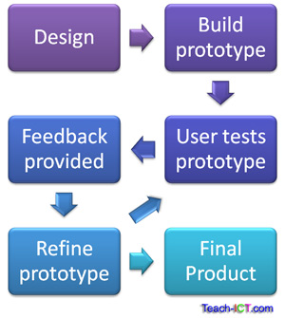

Figure 1: (Teach-itc, 2022) Evolutionary Prototyping

# Resource Requirements:

**Software Requirements**

* IDE VS code
* HTML, CSS, JavaScript, Bootstrap and React js will be used for the front-end.
* Node JS, Next JS will be used for backend
* MySQL will be used for the database.

**Hardware Requirement**

* A reliable Laptop to work on so MacBook pro will be used for this project

# Work Breakdown Structure

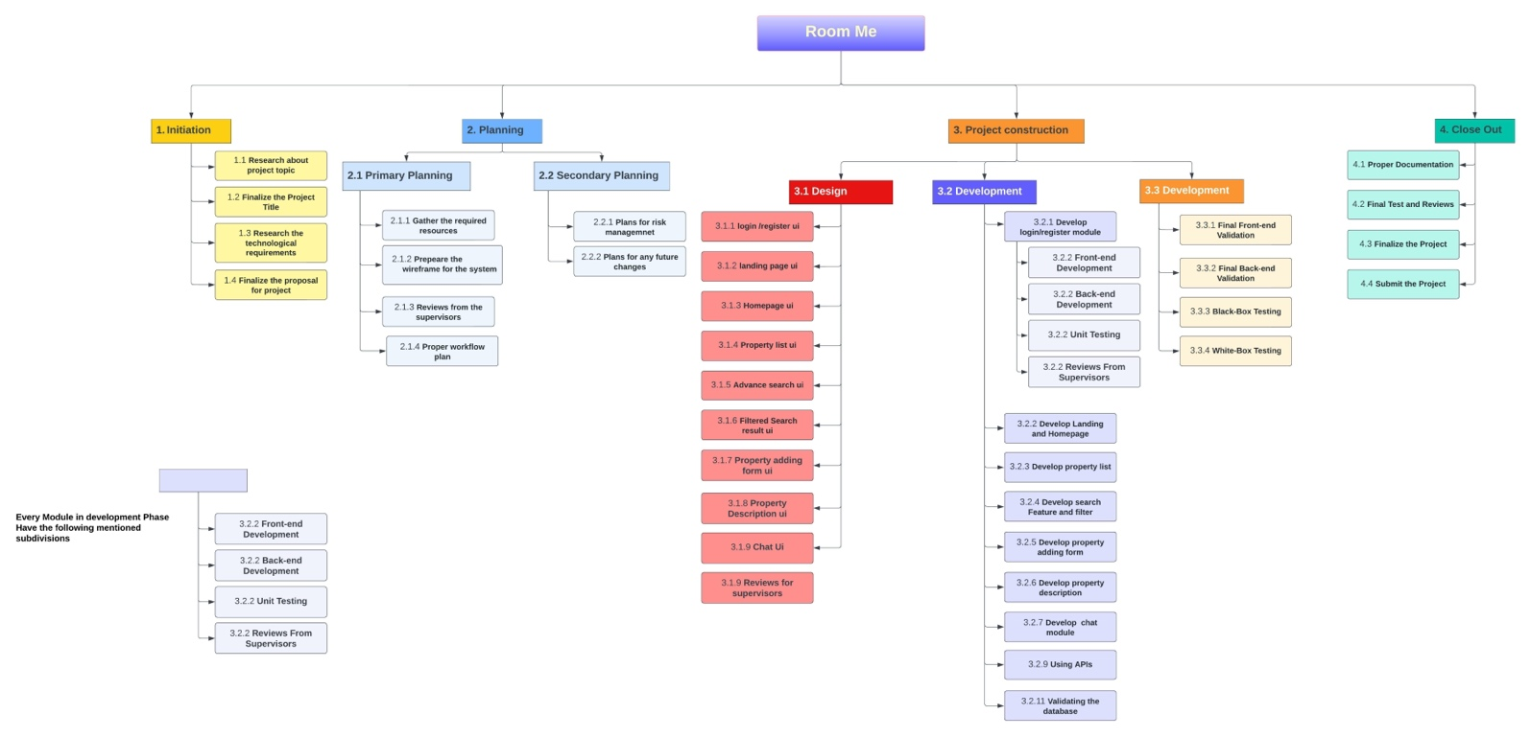

Figure 2: Work Breakdown Structure

# Milestone

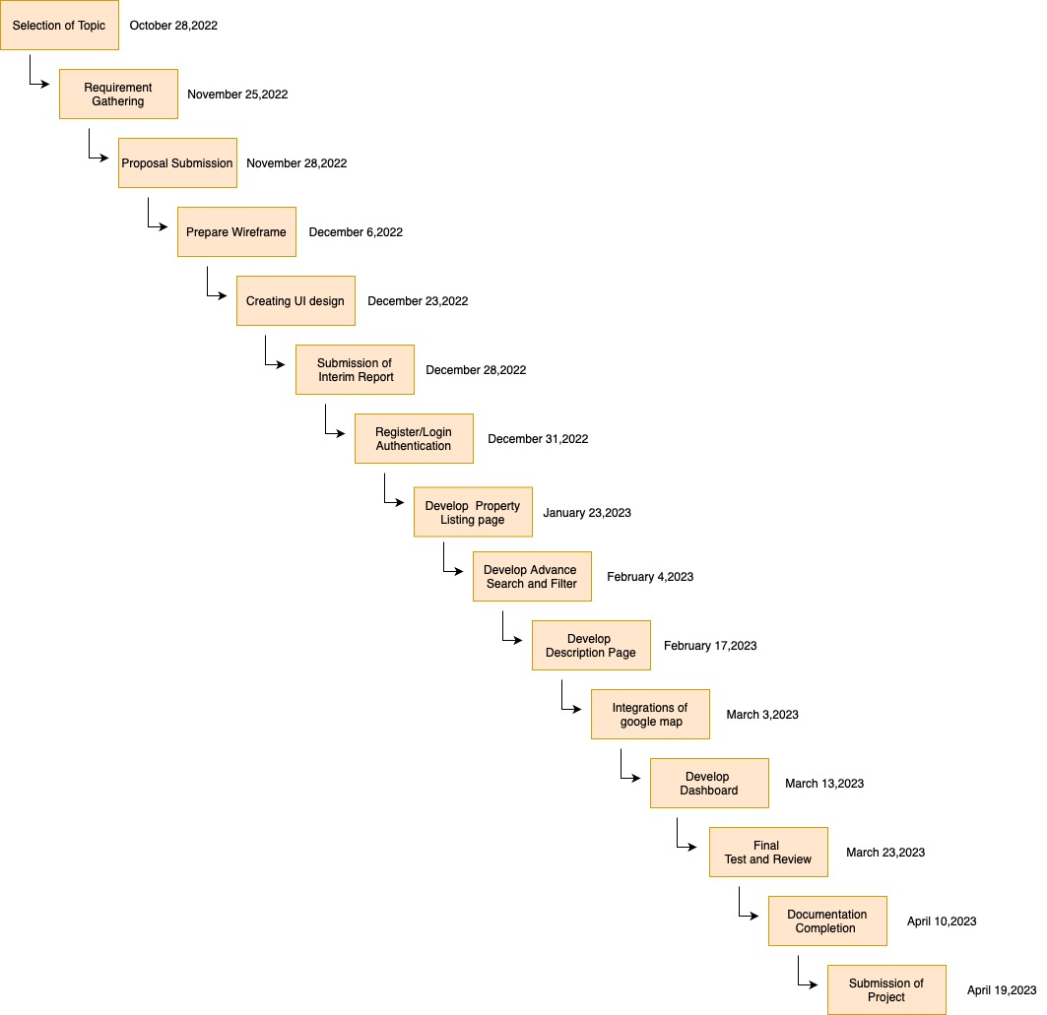

Figure 3: Milestone

# Gantt Chart

=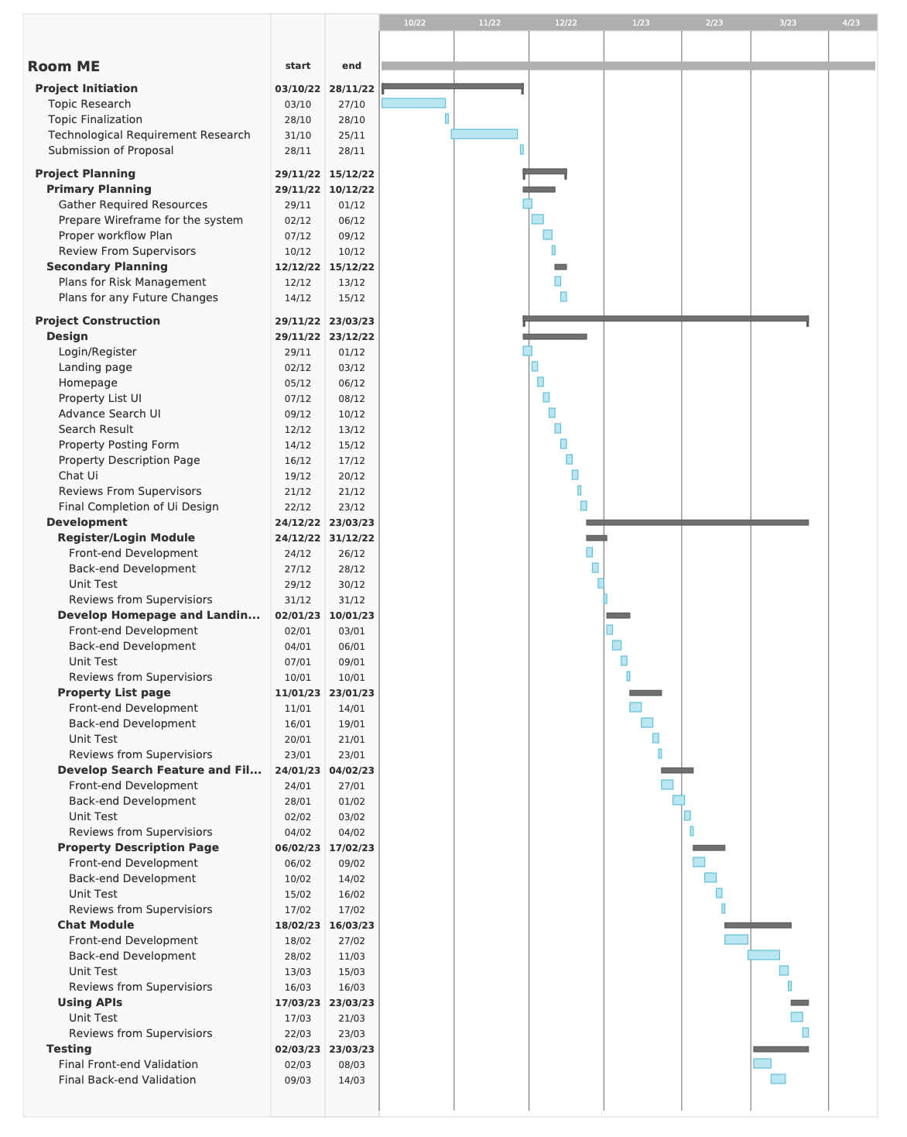

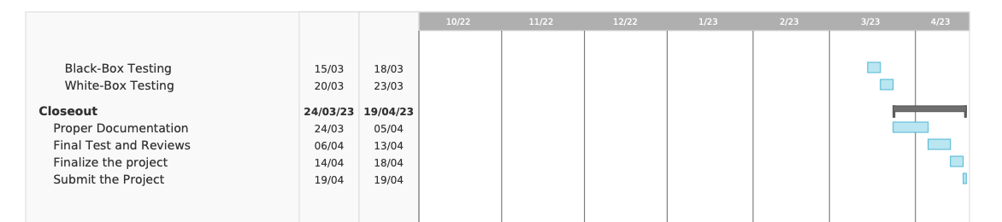

Figure 4: Gantt Chart

# Development to date

## Use Case Diagram

## Use Case Diagram

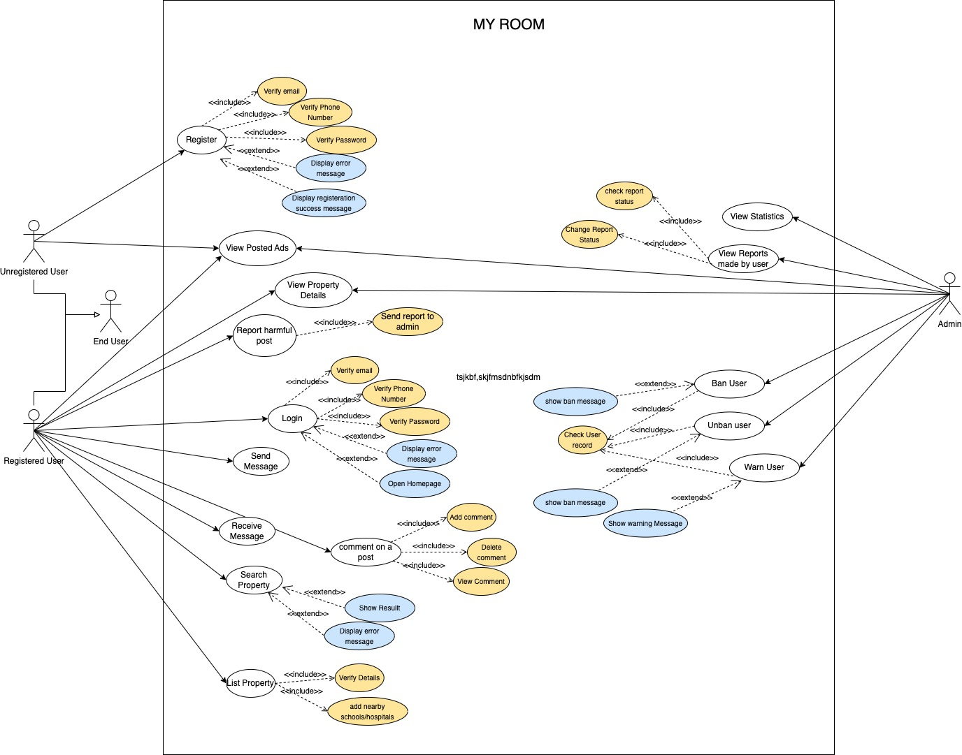

Figure 5: Use Case Diagram

1. Whole System Wireframe

# 

# Landing Page Wireframe



* 1. Login Page



* 1. Register Page



* 1. Home Page



* 1. Property Description Page



* 1. Nav-link Room/Apartment Page



# 6. Conclusion

This web application for finding and selling the room/apartments may act as the best possible and effective system for the people living in Nepal. Specially to those who are constantly migrating from one place to another because of work or their study. However, this web app system is only the starting phase of this project with limited features as of now however it can be upscaled to a large-scale project with added features, products and security. This project could completely change the real-estate scenario of Nepal in its large-scale form.

The experience and knowledge gained while working on this project will surely help in the future as well to get kickstarted as a web developer.

# Bibliography

SpringerLink, January 01, 1970. *SpringerLink.* [Online]   
Available at: https://link.springer.com/referenceworkentry/10.1007/978-1-4020-8265-8_201039#:~:text=Evolutionary%20prototyping%20is%20a%20software,until%20the%20final%20product%20emerges.  
[Accessed 10 November 2022].

Anon., 2022. *Teach.* [Online]   
Available at: https://www.teach-ict.com/as_a2_ict_new/ocr/A2_G063/331_systems_cycle/prototyping_RAD/miniweb/pg3.htm  
[Accessed 10 November 2022].

Teach-itc, 2022. *Teach.* [Online]   
Available at: https://www.teach-ict.com/as_a2_ict_new/ocr/A2_G063/331_systems_cycle/prototyping_RAD/miniweb/pg3.htm  
[Accessed 10 November 2022].

Digite, 2019. *Digite.* [Online]   
Available at: https://www.digite.com/agile/scrum-methodology/  
[Accessed 20 November 2022].

Minott, C., 2022. *Study.com.* [Online]   
Available at: https://study.com/learn/lesson/rational-unified-process-methodology-examples.html  
[Accessed 20 November 2022].